**Supplementary Materials**

1. **Methods**
   1. **Cognitive Diagnoses**

CN individuals from ADNI and OASIS had no significant impairment in memory or cognitive functions or activities of daily living, and no significant memory concern. In ADNI, a differentiation of CN and SCD was only made starting from ADNI-2, causing us to exclude individuals from ADNI-1 due to uncertain diagnosis. In OASIS, SCD individuals who reported memory concerns or whose spouse or clinician mentioned concerns as assessed in the USD-b9 questionnaire (n=10), were discarded from our sample due to the small sample size. To be considered SCD, either the study participant, an informant, or the clinician (in ADNI)/the study participant (in DELCODE) reported a significant memory concern in the absence of objective impairment of memory of cognitive function. SCD in ADNI were recruited from the general population, whereas SCD in DELCODE were recruited from memory clinics. An MCI diagnosis was provided to individuals with measurable impairment in cognitive function in the absence of dementia or significant impairments of daily living.

* 1. **Pre-processing**

For FDG-PET, preprocessing was performed on average scans of the given time intervals using the Statistical Parametric Mapping 12 toolbox (SPM12; [www.fil.ion.ucl.ac.uk](http://www.fil.ion.ucl.ac.uk)) in MATLAB (r2021b, The MathWorks Inc). All FDG-PET scans were aligned to the anterior commissure/posterior commissure, and subsequently co-registered and normalized to the tissue probability map (TPM) template in standard MNI152 space. Finally, standardized uptake value ratios (SUVRs) were calculated (reference: pons1).

For MRI, first, denoising (spatial-adaptive Non-Local Means), spatial registration, bias correction and skull striping were applied. The scans were then segmented by an adaptive maximum a posteriori approach2 with a partial volume model3. The Geodesic Shooting Algorithm was used for the nonlinear transformation.

To extract regional averages from 90 cortical and sub-cortical brain regions, we used the AAL1 atlas. The spatial overlap of AAL1 and template images in standard space, such as TPM, is sub-optimal, therefore, to avoid strong influence of zero-valued voxels, we resized AAL1 to fit the TPM template by only considering those voxels or AAL which corresponded to a gray matter tissue probability of at least 0.3 in TPM. Given the limited spatial resolution of PET images compared to MRI, computation of non-zero means would have falsified our comparison between modalities.

* 1. **Outlier exclusion**

Outlier exclusion was performed in the outer cross-validation loop to ensure data quality in an automated manner. Interquartile ranges (IQRs) were inferred from the CNADNI training sets. Subjects outside 6xIQR were removed from the training and respective test sets of CNADNI and CNOASIS. Importantly, as previous works have shown, MCI and even SCD subjects show an advanced brain age, which likely translates to a reduced signal in age-relevant brain regions4. Thus, outlier exclusion was not applied to the patient samples.

* 1. **Hyperparameters**

For both the support vector, and relevance vector regression models, the following hyperparameters were available for tuning:

**Kernel**: [‘linear’, ‘rbf’, ‘poly’] # kernel type to be used in algorithm  
**Degree**: [2, 3] # degree if kernel is polynomial

For support vector regression, we additionally tuned the regularization parameter C. Unlike support vector regression, relevance vector regression does not involve a margin-based optimization problem that requires C to control the trade-off between fitting the training data and controlling the model complexity.  
**C**: [0.001, 0.01, 0.1, 1, 10, 100, 500] # regularization parameter (strength of regularization is inversely proportional to C)

1. **Bias correction**

Brain age is subject to a frequently reported bias, in which the brain age of older individuals is under- and the brain age of younger individuals is overestimated5, regardless of the data or method under consideration. Here, bias correction parameters were estimated using a linear model5 in the validation set, and subsequently applied to all test sets. The final brain age was calculated using slope (ɑ) and an intercept (β) as follows:

$${Predicted age}_{corrected with CA}={Predicted age}_{uncorrected}-(α*CA+β)$$

1. **Feature importance**

To understand feature importance of our brain age estimation frameworks beyond single brain regions, we summarized AAL atlas regions into lobes as follows:

* **Frontal:** Precentral_L, Precentral_R, Frontal_Sup_L, Frontal_Sup_R, Frontal_Sup_Orb_L, Frontal_Sup_Orb_R, Frontal_Mid_L, Frontal_Mid_R, Frontal_Mid_Orb_L, Frontal_Mid_Orb_R, Frontal_Inf_Oper_L, Frontal_Inf_Oper_R, Frontal_Inf_Tri_L, Frontal_Inf_Tri_R, Frontal_Inf_Orb_L, Frontal_Inf_Orb_R, Rolandic_Oper_L, Rolandic_Oper_R, Supp_Motor_Area_L, Supp_Motor_Area_R, Olfactory_L, Olfactory_R, Frontal_Sup_Medial_L, Frontal_Sup_Medial_R, Frontal_Med_Orb_L, Frontal_Med_Orb_R, Rectus_L, Rectus_R, Cingulum_Ant_L, Cingulum_Ant_R
* **Temporal:** Insula_L, Insula_R, Fusiform_L, Fusiform_R, Heschl_L, Heschl_R, Temporal_Sup_L, Temporal_Sup_R, Temporal_Pole_Sup_L, Temporal_Pole_Sup_R, Temporal_Mid_L, Temporal_Mid_R, Temporal_Pole_Mid_L, Temporal_Pole_Mid_R, Temporal_Inf_L, Temporal_Inf_R
* **Limbic:** Cingulum_Mid_L, Cingulum_Mid_R, Cingulum_Post_L, Cingulum_Post_R, Hippocampus_L, Hippocampus_R, ParaHippocampal_L, ParaHippocampal_R, Amygdala_L, Amygdala_R
* **Occipital:** Calcarine_L, Calcarine_R, Lingual_L, Lingual_R, Occipital_Sup_L, Occipital_Sup_R, Occipital_Mid_L, Occipital_Mid_R, Occipital_Inf_L, Occipital_Inf_R
* **Parietal:** Cuneus_L, Cuneus_R, Postcentral_L, Postcentral_R, Parietal_Sup_L, Parietal_Sup_R, Parietal_Inf_L, Parietal_Inf_R, SupraMarginal_L, SupraMarginal_R, Angular_L, Angular_R, Precuneus_L, Precuneus_R, Paracentral_Lobule_L, Paracentral_Lobule_R
* **Subcortical:** Caudate_L, Caudate_R, Putamen_L, Putamen_R, Pallidum_L, Pallidum_R, Thalamus_L, Thalamus_R

1. **Measures of cognitive performance**

The ADNI-MEM combines several scores used to evaluate individuals’ memory performance from the Rey Auditory Verbal Learning Test, Alzheimer’s Disease Assessment Scale and Mini Mental State Exam. The ADNI-EF is a summary score of several executive function tasks: Category Fluency, Trails, Digit span backwards, Wechsler Adult Intelligence Scale-R Digit Symbol Substitution, Number Cancellation, and Clock Drawing items. Correlations of BAG with cognitive performance were tested against a Bonferroni-corrected α-level of .025 (0.05/2).

1. **Measures of AD neuropathology**

For AV45-PET, mean SUVR are publicly available from previous analyses6. CSF Aβ1-42, and p-Tau181/ Aβ1-42 were acquired via lumbar puncture and analyzed using the Roche Elecsys® immunoassays7. The number of tau PET scans already evaluated for SUVR in the current cohorts was too small to include this biomarker in the current analyses. Correlations of BAG with AD neuropathology were tested against a Bonferroni-corrected α-level of 0.0125 (0.05/2).

1. **Results**
   1. **Bias correction**

Bias correction successfully removed bias in all samples except the MRI-based MCIADNI predictions.

|  |  |  |  |
| --- | --- | --- | --- |
| **Table SM1. Remaining correlation between BAG and age after bias correction in all cohorts** | | | |
|  | Modality | *n* | Bias |
| **CNADNI** | MRI | 175+ | r = .016  95% CI [-.13, .16] |
| FDG-PET | 175+ | r = -.022  95% CI [--.17, .13] |
| **CNOASIS** | MRI | 49+ | r = -.149  95% CI [-.37, .09] |
| FDG-PET | 49+ | r = -.058  [-.29, .18] |
| **SCDADNI** | MRI | 102 | r = -.075  95% CI [-.27, .12] |
| FDG-PET | 102 | r = -.055  95% CI [-.25, .14] |
| **MCIADNI** | MRI | 595 | r = .140**  95% CI [.06, .22] |
| FDG-PET | 595 | r = .030  95% CI [-.05, .11] |
| **SCDDELCODE** | FDG-PET | 88 | r = -.022  95% CI [-.23, .19] |
| **MCIDELCODE** | MRI | 80 | r = -.019  95% CI [-.24, .2] |
| **Notes.** Remaining bias (the correlation coefficient between BAG and age) after bias correction was assessed using Pearson correlation. +trend significant with α = 0.1, * significant with α = 0.05, ** significant with α = 0.01 | | | |

* 1. **Accuracy of estimated brain age using the composite atlas**

Brain age estimation using the composite Schaeffer and Tian atlas (216 regions of interest) was largely comparable to results obtained from the AAL atlas. We found no significant difference between modalities in the accuracy of brain age estimation in the CN cohorts. While the difference in MAE was not significant, generalization performance to the OASIS dataset was compromised compared to CNADNI, especially regarding r-squared values. Moreover, models trained with the composite atlas showed no significant brain age advancement for SCDADNI.

|  |  |  |  |  |  |  |  |  |  |
| --- | --- | --- | --- | --- | --- | --- | --- | --- | --- |
| **Table SM2.** Accuracy of estimating chronological age from FDG-PET and MRI scans using the composite atas. | | | | | | | | | |
|  | Modality | *n* | MAE | Range | ME | R² | **Accuracy**  MAE MRI vs FDG-PET | **Generalizability**  MAE current vs CNADNI | **Brain age advancement**  MEcurrent vs CNADNI |
| **CNADNI** | MRI | 173+ | 2.75 | [-.8, 10.3] | -0.07 (3.57) | .67 | t = -0.87  95% CI [-0.66, 0.25] | NA | NA |
| FDG-PET | 173+ | 2.55 | [-12.9, 13.6] | -0.16 (3.39) | .70 | NA |
| **CNOASIS** | MRI | 41+ | 3.05 | [-6.6, 10.6] | 0.67 (4.03) | .08 | t = -0.82  95% CI [-1.54, 0.65] | t = 1.07  95% CI [-0.64, 2.11] | t = 0.66  95% CI [-0.61, 1.20] |
| FDG-PET | 41+ | 2.60 | [-6.8, 5.5] | -1.0 (3.15) | .36 | t = 0.16  95% CI [-0.65, 0.76] | t = -1.51  95% CI [-1.95, 0.27] |
| **SCDADNI** | MRI | 102 | 2.37 | [-6.8, 5.9] | -0.00 (2.9) | .73 | t = 0.37  95% CI [-0.34, 0.49] | NA | t = 1.16  95% CI [-0.72, 0.84] |
| FDG-PET | 102 | 2.45 | [-5.6, 10.5] | 0.14 (3.03) | .71 | NA | t = 0.75  95% CI [-0.48, 1.08] |
| **MCIADNI** | MRI | 595 | 3.705 | [-8.1, 13.8] | 2.34 (3.92) | .57 | t = -9.93**  95% CI [-1.55, 1.04] | NA | t = 7.62**  95% CI [1.78, 3.02] |
| FDG-PET | 595 | 2.41 | [-11.3, 10.9] | 0.42 (3.05) | .8 | NA | t = 2.02*  95% CI [0.01, 1.14] |
| **SCDDELCODE** | FDG-PET | 88 | 2.53 | [-5.1, 7.8] | 1.59 (2.87) | .65 | NA | NA | t = 4.38**  95% CI [0.96, 2.54] |
| **MCIDELCODE** | MRI | 80 | 3.51 | [-9.3, 12.8] | 2.07 (4.00) | .41 | NA | NA | t = 4.08**  95% CI [1.10, 3.17] |
| *Notes.* +After outlier exclusion using CN train set (IQR > 6). Accuracy differences were assessed with paired t-tests, while generalizability and brain age advancement were tested with standard t-tests. +trend significant with α = 0.1, * significant with α = 0.05, ** significant with α = 0.01 | | | | | | | | | |

* 1. **Hyperparameters**

For reproducibility, Table SM1 outlines hyperparameter configurations of the final models.

|  |  |  |  |  |  |
| --- | --- | --- | --- | --- | --- |
| **Table SM3. Final models with optimal hyperparameter configurations.** | | | | | |
|  |  | **Model** | **C** | **Kernel** | **Degrees** |
| **MRI** | Model 1 | RVR | NA | Rbf | NA |
| Model 2 | RVR | NA | Linear | NA |
| Model 3 | SVR | 1 | Linear | NA |
| Model 4 | RVR | NA | Rbf | NA |
| Model 5 | SVR | 1 | Linear | NA |
| **FDG-PET** | Model 1 | RVR | NA | Linear | NA |
| Model 2 | RVR | NA | Linear | NA |
| Model 3 | SVR | 1 | Rbf | NA |
| Model 4 | RVR | NA | Linear | NA |
| Model 5 | RVR | NA | Linear | NA |

* 1. **Prediction of Cognitive Outcome**

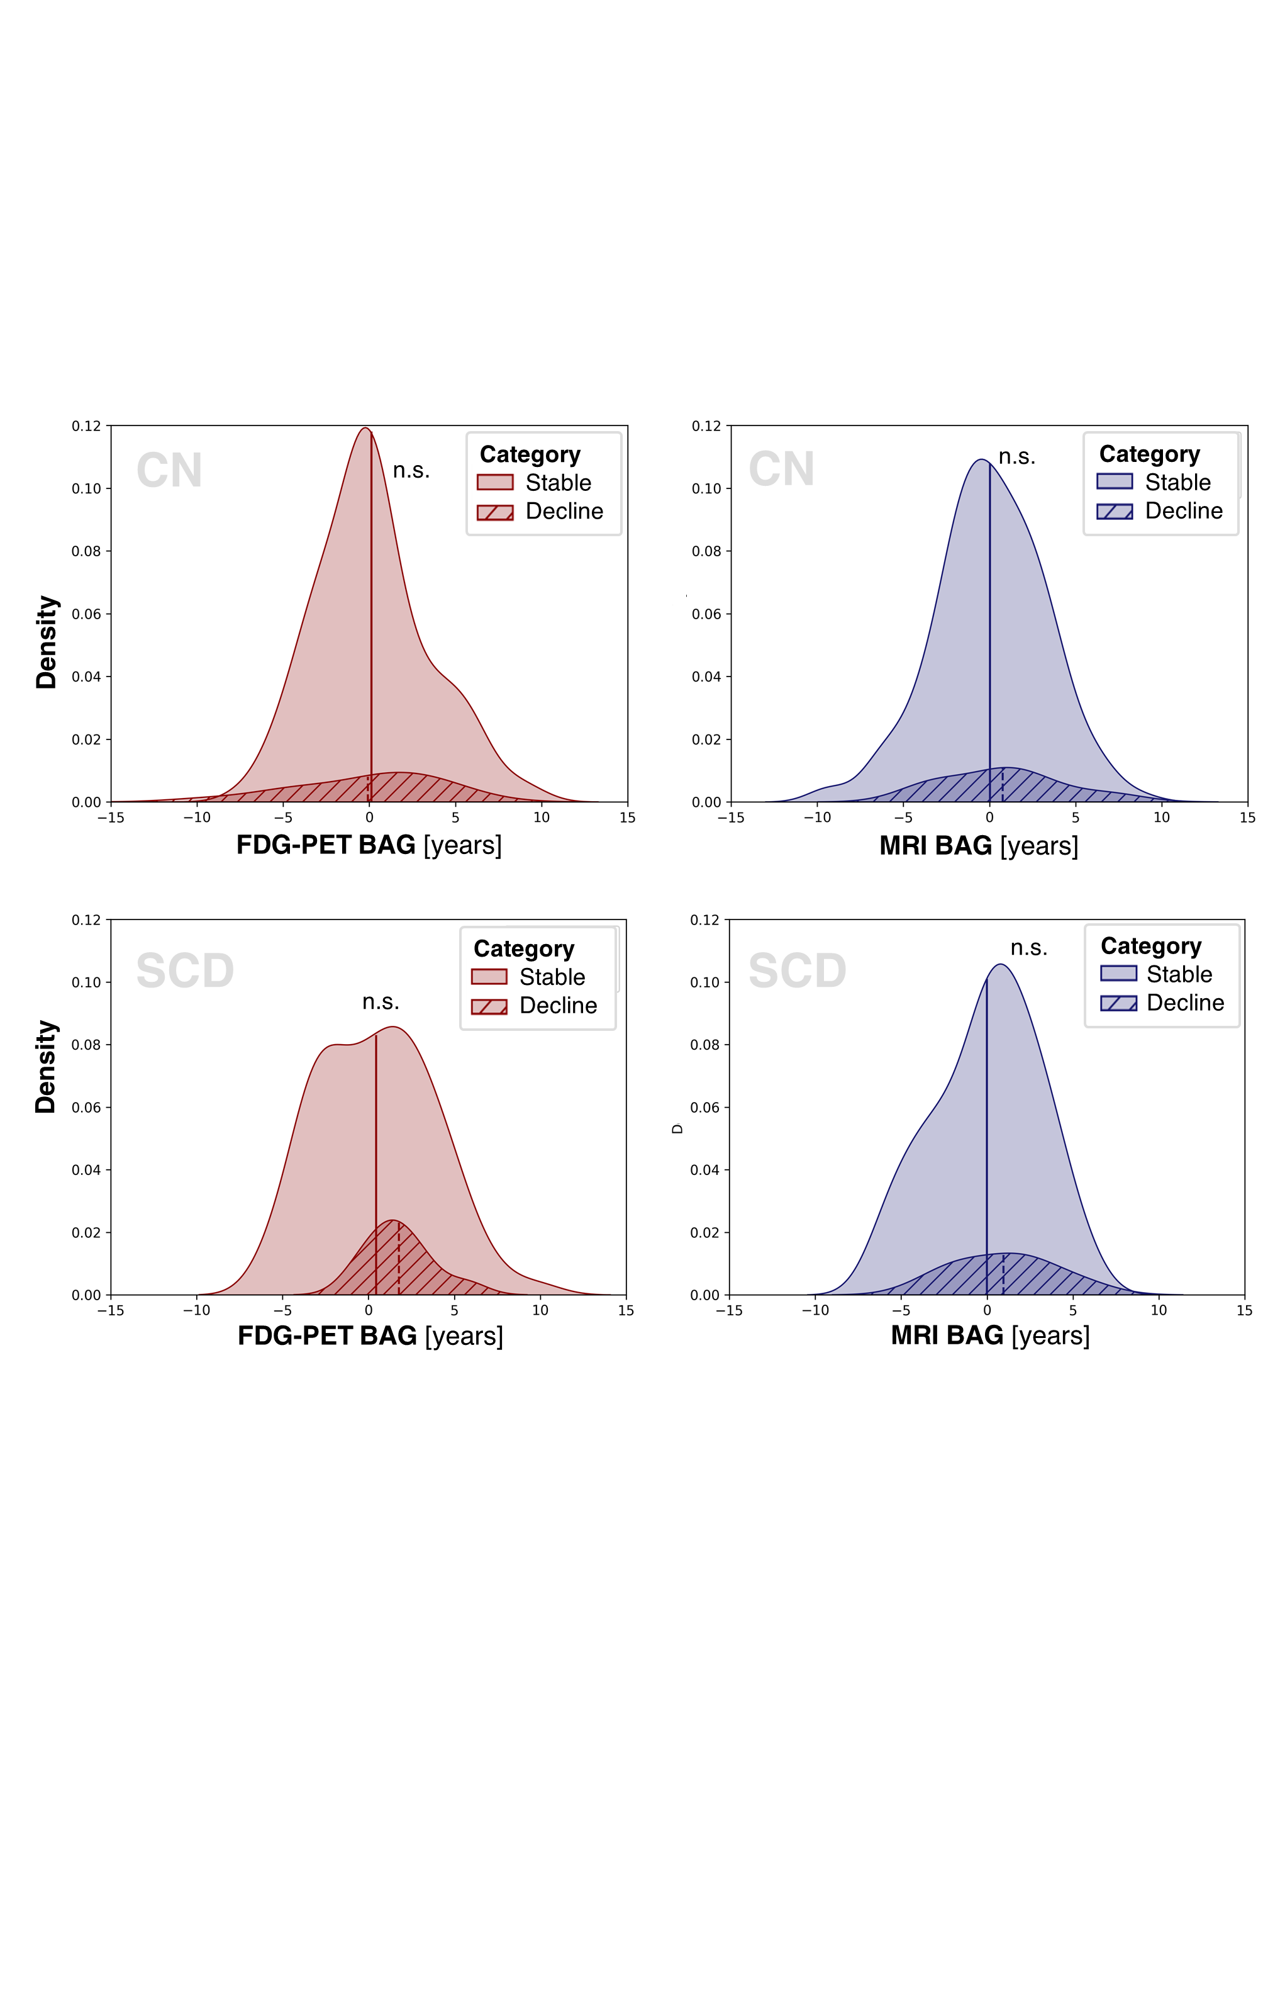

**FIGURE SM1 BAG for the Prediction of Cognitive Outcome.** Density plots showing MRI and BAG distribution by cognitive outcome in CNADNI (top)) and SCDADNI (bottom)).

**References**

1. Verger A, Doyen M, Campion JY, Guedj E. The pons as reference region for intensity normalization in semi-quantitative analysis of brain 18FDG PET: application to metabolic changes related to ageing in conventional and digital control databases. *EJNMMI Res*. 2021;11(1):1-7. doi:10.1186/s13550-021-00771-0

2. Rajapakse JC, Giedd JN, Rapoport JL. Statistical approach to segmentation of single-channel cerebral mr images. *IEEE Trans Med Imaging*. 1997;16(2). doi:10.1109/42.563663

3. Tohka J, Zijdenbos A, Evans A. Fast and robust parameter estimation for statistical partial volume models in brain MRI. *Neuroimage*. 2004;23(1). doi:10.1016/j.neuroimage.2004.05.007

4. Gaser C, Franke K, Klöppel S, Koutsouleris N, Sauer H. BrainAGE in Mild Cognitive Impaired Patients: Predicting the Conversion to Alzheimer’s Disease. *PLoS One*. 2013;8(6):e67346. doi:10.1371/journal.pone.0067346

5. Beheshti I, Nugent S, Potvin O, Duchesne S. Bias-adjustment in neuroimaging-based brain age frameworks: A robust scheme. *NeuroImage Clin*. 2019;24:102063. doi:10.1016/j.nicl.2019.102063

6. Landau S, Jagust W. *Florbetapir Processing Methods*.; 2011.

7. Blennow K, Shaw LM, Stomrud E, et al. Predicting clinical decline and conversion to Alzheimer’s disease or dementia using novel Elecsys Aβ(1–42), pTau and tTau CSF immunoassays. *Sci Rep*. 2019;9(1). doi:10.1038/s41598-019-54204-z